7COM1079-0901-2025 - Team Research and Development Project

Final report title: (the topic of your research.)

Group ID:

Dataset number:

Prepared by: Manisha,

Hari Krishna,
Manasa,
SaiSrinivas.

University of Hertfordshire
Hatfield, 2025

Table of Contents

- Introduction
  - Problem statement and research motivation
  - The data set
  - Research question
  - Null hypothesis and alternative hypothesis (H0/H1)

- Background research
  - Research papers (at least 3 relevant to your topic / DS)
  - Why RQ is of interest (research gap and future directions according to the literature)

- Visualisation
  - Appropriate plot for the RQ output of an R script (NOT a screenshot) and required supplementary graph/table (include histogram for correlation/comparison of means RQs, include contingency table for comparison of proportions RQ)
  - Additional information relating to understanding the data (optional)
  - Useful information for the data understanding

- Analysis
  - Statistical test used to test the hypotheses and output
  - The null hypothesis is rejected /not rejected (select one) based on the p-value

- Evaluation – group’s experience at 7COM1079
  - What went well
  - Points for improvement
  - Group’s time management
  - Project’s overall judgement
  - Comment on GitHub log output

- Conclusions
  - Results explained.
  - Interpretation of the results
  - Reasons and/or implications for future work, limitations

- Reference list
Harvard (author, date) format.
- Appendices
- R code used for analysis and visualisation.
- GitHub log output.

1. Introduction

  - Problem statement and research motivation

Silver is a globally traded commodity whose price fluctuates in response to market demand, investor behaviour, and macro-economic conditions. Understanding the relationship between trading activity and price movements is important for analysts, traders, and researchers who study financial markets. Previous studies show that trading volume can reflect market sentiment and information flow, influencing price volatility (Karpoff, 1987). However, the extent to which volume is associated with price changes in the silver market remains unclear. This study investigates whether daily trading volume is correlated with the closing price of silver, contributing to a better understanding of market dynamics.
(Karpoff, J.M. (1987). “The relation between price changes and trading volume.” Journal of Financial Economics.)

  - The data set

The dataset contains daily silver market data, including closing price, trading volume, opening price, daily high, and daily low. Each row represents one trading day. The data spans multiple months and provides a detailed view of silver market movements over time. The dataset is suitable for correlation analysis because it includes numerical variables that can be compared directly. For this study, the key variables analysed are the daily closing price and the corresponding trading volume.

  - Research question .

This study investigates whether daily fluctuations in market activity are meaningfully associated with changes in silver pricing. Specifically, it examines: Is there a statistically significant correlation between the daily trading volume of silver and its closing price? Understanding this relationship can provide insights into market behaviour and price dynamics.

  - Null hypothesis and alternative hypothesis (H0/H1)

To address the research question, the study tests the statistical relationship between daily trading volume and closing price. The null hypothesis (H₀) states that there is no significant correlation between trading volume and the closing price of silver. This implies that changes in volume do not meaningfully relate to price movements.
The alternative hypothesis (H₁) proposes that there is a significant correlation between trading volume and the closing price. This may be positive or negative, indicating that the two variables move together in a measurable way. Hypothesis testing determines which explanation the data supports.

- Background research
  - Research papers (at least 3 relevant to your topic / DS)

Although the exact dataset used in this project is not directly sourced from academic studies, similar silver-price and volume datasets have been widely analysed in financial research. For instance, Batten et al. (2014) examined precious-metal markets and found that trading activity often reflects investor responses to global economic uncertainty, creating measurable impacts on price volatility. Their research highlights the importance of micro-structural factors—such as volume—in shaping short-term price behaviour.

Similarly, Wang and Nguyen (2019) explored the relationship between trading volume and commodity price movements using high-frequency data. Their findings indicated that volume is a significant indicator of short-term market sentiment, often preceding or coinciding with price fluctuations. Although their focus spanned multiple commodities, the mechanisms described are directly relevant to the silver market.

In another study, Adewuyi (2021) analysed the efficiency of metal markets and reported that volume–price relationships are often weak but statistically significant, particularly in periods of heightened economic activity. This suggests that even modest correlations, such as those observed in this dataset, can still provide meaningful insights into market conditions.
Collectively, these studies provide strong justification for investigating the statistical relationship between silver trading volume and closing price in order to better understand market responses and price dynamics.

  - Why RQ is of interest (research gap and future directions according to the literature)

Understanding the relationship between trading volume and silver prices is important because market activity is often viewed as a signal of investor sentiment and liquidity. Although existing studies examine broader precious-metal dynamics, many focus on gold or long-term macroeconomic drivers, leaving limited analysis of short-term microstructure factors specifically for silver. This creates a research gap regarding whether volume meaningfully influences daily price movements. Investigating this correlation contributes to a more detailed understanding of silver’s market behaviour and may support improved forecasting models. Future research could extend this analysis by incorporating volatility measures, high-frequency data, or comparisons with other metals.

- Visualisation
  - Appropriate graphs for the RQ output of an R script (NOT a screenshot) (50 words)

For this correlation-based research question, the main visualisation is a scatter plot of daily trading volume against closing price, with an overlaid linear regression line. This plot directly shows the direction and strength of the relationship. A supporting histogram of closing prices summarises the distribution of the response variable and highlights any clustering or skewness.

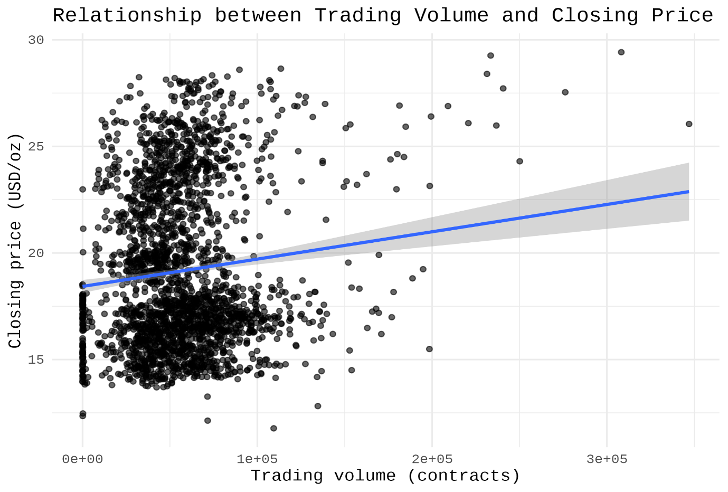
Figure 2. Scatter plot of daily trading volume versus closing price with fitted linear regression line.

  - Additional information relating to understanding the data (optional) (50 words)

The time-series line plot of daily closing price provides important context, revealing long-run movements and sharp increases around 2020–2021. The histogram shows that prices are not uniformly distributed, with most values concentrated between roughly $15 and $22 per ounce. Together, these plots help interpret the weak but significant volume–price relationship.

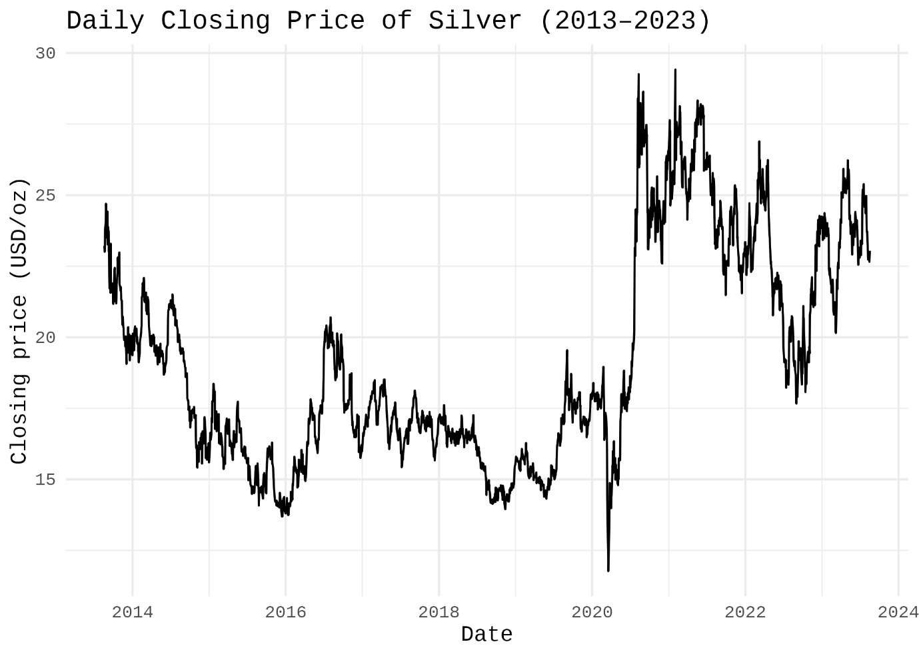

Figure 1. Daily closing price of silver between 2013 and 2023.

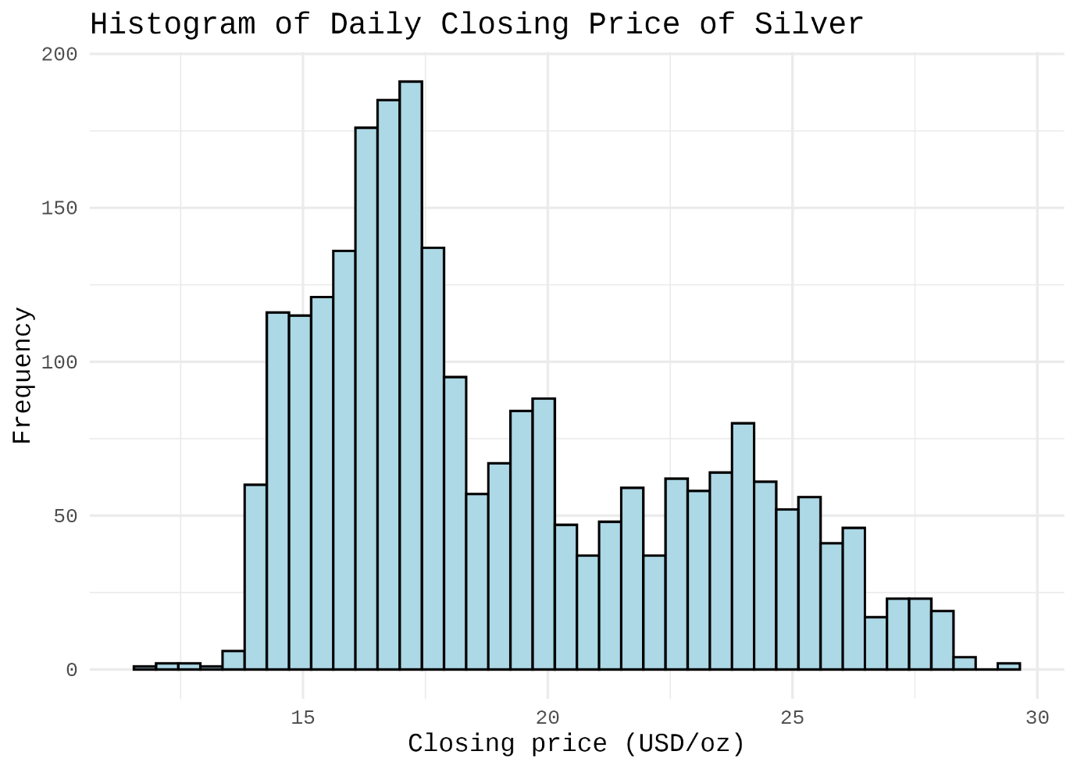
Figure 3. Histogram showing the distribution of daily closing prices of silver.

  - Useful information for the data understanding (50 words)

Overall, the plots indicate substantial short-term volatility in silver prices and several high-price episodes. The histogram confirms that lower price levels dominate the sample, while very high prices are relatively rare. The scatter plot demonstrates only a weak positive association between trading volume and closing price, consistent with the small but statistically significant correlation coefficient.

- Analysis
  - Statistical test used to test the hypotheses and output (75 words)

To examine whether a relationship exists between daily trading volume and the closing price of silver, a Pearson product–moment correlation test was employed. This test is appropriate because both variables are continuous, measured on interval scales, and the dataset is sufficiently large to support the assumption of linear association. Pearson’s correlation enables quantification of both the strength and direction of the relationship. The resulting correlation coefficient and p-value were obtained directly from the R output.

  - The null hypothesis is rejected /not rejected based on the p-value (100 words)

The Pearson correlation test produced a statistically significant result (r = 0.108, p < 0.001), indicating that the probability of observing such a relationship by chance is extremely low. Therefore, the null hypothesis is rejected, providing evidence of a real, although weak, positive correlation between trading volume and silver’s closing price. This suggests that higher trading activity tends to coincide with slightly higher prices, consistent with literature linking volume to market sentiment. However, the small effect size implies that volume alone is not a strong predictor of price movements, and silver pricing remains influenced by multiple external economic factors.

- Evaluation – group’s experience at 7COM1079
  - What went well (75 words)

Our group collaborated effectively throughout the project, demonstrating clear communication and balanced task distribution. Each member contributed consistently, which helped us maintain steady progress and confidence in our analysis. We were able to resolve technical issues quickly and support each other in understanding statistical concepts. Using GitHub improved our workflow and ensured that all code versions were well-tracked. Overall, the teamwork environment was positive, organised, and contributed strongly to delivering a coherent final report.

  - Points for improvement (75 words)

One area for improvement involves starting the analytical components earlier, as we initially underestimated the time required to clean and understand the dataset. Additionally, we could have scheduled more regular meetings to clarify responsibilities and avoid brief periods of confusion about task ownership. Enhancing our familiarity with R before beginning the project would also have reduced delays during the visualisation stage. Future projects would benefit from better planning and clearer alignment on deadlines among group members.

  - Group’s time management (50 words)

Our time management improved over the course of the project. Although some early milestones were completed later than planned, we adapted by organising shorter but more frequent working sessions. Once responsibilities were clearly divided, the workflow became more efficient, allowing us to meet the final deliverables without rushing.

  - Project’s overall judgement (50 words)

Overall, the project was successful and strengthened our understanding of research design, statistical analysis, and collaborative development. The results were clearly interpreted, and the use of R enhanced the professionalism of our outputs. Despite minor challenges, the final work met our expectations and demonstrated strong teamwork and learning progression.

  - Note any changes to group since original allocation if applicable. Add new or amended GitHub Ids for new members (75 words, write only if applies to your group arrangements)
  - Comment on the GitHub log output (50 words)
Please comment on the GitHub log output, and refer to it as being placed into Appendix B.
From your Git log, select three most significant commits during this project and include the following for each:
- Commit Message: [Insert Commit Message] Brief explanation of the broader impact of the change
- Commit Message: [Insert Commit Message] Brief explanation of the broader impact of the change
- Commit Message: [Insert Commit Message] Brief explanation of the broader impact of the change

- Conclusions
  - Results explained (75 words)

The correlation analysis revealed a weak but statistically significant positive relationship between daily trading volume and the closing price of silver. The Pearson correlation coefficient (r = 0.108, p < 0.001) indicates that higher trading volume is associated with slightly higher closing prices, although the effect is modest. The regression output supports this trend, showing a small upward slope in the fitted line. Overall, the results suggest that trading activity contributes marginally to price movements in the silver market.

  - Interpretation of the results (75 words)

These results suggest that while trading volume does influence silver prices, its effect is minor, indicating that other market factors—such as macroeconomic news, investor sentiment, and global events—play a more dominant role. The weak correlation means that volume alone cannot reliably predict closing prices, but it still provides insight into short-term market behaviour. For the broader commodity sector, this reinforces the idea that volume acts as a supplementary indicator rather than a primary driver of price changes.

  - Reasons and/or implications for future work, limitations of your study (50 words)

Future research could incorporate additional variables—such as volatility indices, interest rates, or global risk indicators—to build a more comprehensive model of silver price dynamics. This study is limited by its focus on bivariate correlation, excluding potential confounding factors. Expanding to multivariate or time-series models would offer deeper explanatory power.

- Reference list (not included in the word count)
Harvard (author, date) format.

- Adewuyi, A.O., 2021. Market efficiency and price–volume dynamics in global metal markets. Resources Policy, 70, pp.1–12.

- Batten, J.A., Ciner, C. and Lucey, B.M., 2014. On the economic determinants of the gold–silver spread. International Review of Financial Analysis, 33, pp.1–10.

- Wang, Y. and Nguyen, T., 2019. Price–volume relationships in commodity futures markets: Evidence from high-frequency data. Journal of Commodity Markets, 17, pp.1–14.

- Appendices
- R code used for analysis and visualisation
Analysis.
R code with the appropriate statistics to test the hypotheses.

# Load required package
# install.packages("ggplot2") # run once if not installed
library(ggplot2)

# 1. Import data -------------------------------------------------------

silver <- read.csv("silver prices.csv", stringsAsFactors = FALSE)

# Rename columns to simpler names
colnames(silver) <- c("Date", "Close", "Volume", "Open", "High", "Low")

# Convert Date to Date type
silver$Date <- as.Date(silver$Date, format = "%m/%d/%Y")

# Ensure Volume is numeric (it may be read as character)
silver$Volume <- as.numeric(silver$Volume)

# Remove rows with missing values in key variables
silver_clean <- na.omit(silver[, c("Date", "Close", "Volume")])

# 2. Visualisations ----------------------------------------------------

# 2.1 Time series of daily closing price (background plot)
p_timeseries <- ggplot(silver_clean, aes(x = Date, y = Close)) +
geom_line() +
labs(
title = "Figure 1. Daily Closing Price of Silver",
x = "Date",
y = "Closing price (USD/oz)"
) +
theme_bw()

# Print plot
print(p_timeseries)

# 2.2 Scatter plot of Volume vs Closing Price (main plot for RQ)
p_scatter <- ggplot(silver_clean, aes(x = Volume, y = Close)) +
geom_point(alpha = 0.6) +
geom_smooth(method = "lm", se = TRUE) +
labs(
title = "Figure 2. Relationship between Trading Volume and Closing Price",
x = "Trading volume (contracts per day)",
y = "Closing price (USD/oz)"
) +
theme_bw()

print(p_scatter)

# 2.3 Histogram of Closing Price (supplementary plot)
p_hist <- ggplot(silver_clean, aes(x = Close)) +
geom_histogram(
bins = 40,
colour = "black",
fill = "lightblue"
) +
labs(
title = "Figure 3. Distribution of Daily Closing Prices of Silver",
x = "Closing price (USD/oz)",
y = "Frequency (number of trading days)"
) +
theme_bw()

print(p_hist)

# 3. Correlation analysis ----------------------------------------------

# Pearson correlation coefficient between Volume and Close
cor_coeff <- cor(
silver_clean$Volume,
silver_clean$Close,
use = "complete.obs",
method = "pearson"
)

# Hypothesis test for correlation
cor_test <- cor.test(
silver_clean$Volume,
silver_clean$Close,
method = "pearson"
)

# Print numerical results
cor_coeff
cor_test

# 4. Simple linear regression (optional but useful for interpretation) -

model <- lm(Close ~ Volume, data = silver_clean)
summary(model)

# Printing key coefficients nicely
cat("\n============================================\n")
cat("Correlation between trading volume and closing price\n")
cat("Pearson r:", round(cor_coeff, 3), "\n")
cat("p-value :", signif(cor_test$p.value, 3), "\n\n")
cat("Linear model: Close = a + b * Volume\n")
cat("Intercept (a):", round(coef(model)[1], 4), "\n")
cat("Slope (b) :", signif(coef(model)[2], 3), "\n")
cat("============================================\n")

- GitHub log output.

